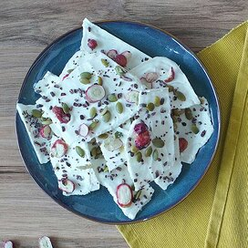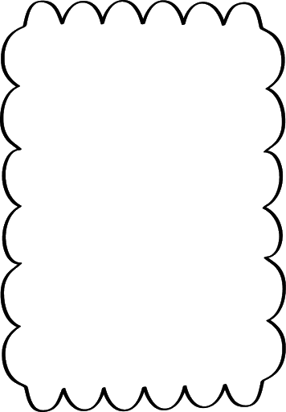

**Yogurt Bark**

**Ingredients:**

1 (17.6 oz) container full-fat Greek yogurt

2 tablespoons maple syrup, or to taste

¼ teaspoon vanilla extract

¼ cup sliced almonds

¼ cup freez0dried blueberries

2 tablespoons cacao nibs

**Directions:**

1. Line two 9-inch rimmed baking sheets with parchment paper.
2. Wisk together yogurt, maple syrup, and vanilla extract. Divide mixture between the 2 baking sheets and spread out using a spatula until about 1/4 –inch thick. Scatter sliced almonds, dried blueberries, and cacao nibs evenly over each baking sheet.
3. Place baking sheets in the freezer for at least 3 hours, or overnight. Remove from freezer and roughly break or slice into about 2 dozen pieces.

**Cook’s Notes:**

You can use honey to sweeten the yogurt instead of maple syrup and substitute chopped dark chocolate for the cacao nibs. Store any leftovers in the freezer. Once frozen, you can store pieces of frozen bark in a plastic bag.

**Nutrition Facts (Per Serving)**

Calories 47 Prep: 5 minutes

Protein 1.5 g (3% DV) Additional: 3 hours

Carbohydrates 3.7 g (1% DV) Total: 3 hours 5 minutes

Fat 3 g (5% DV) Servings: 24

Cholesterol 4.7 mg (2% DV) Yields: 24 servings

Sodium 14.8 mg (1% DV)